**INTRODUCTION:**

Mental health is essential to our overall well-being and as important as physical health. When we feel mentally well, we can work productively, enjoy our free time, and contribute actively to our communities.

In recent years, there has been increasing acknowledgement of the important role mental health plays in achieving global development goals, as illustrated by the inclusion of mental health in the Sustainable Development Goals. Depression is one of the leading causes of disability. Suicide is the second leading cause of death among 15-29-year-olds. People with severe mental health conditions die prematurely – as much as two decades early – due to preventable physical conditions.

Despite progress in some countries, people with mental health conditions often experience severe human rights violations, discrimination, and stigma.

Many mental health conditions can be effectively treated at relatively low cost, yet the gap between people needing care and those with access to care remains substantial. Effective treatment coverage remains extremely low.

Increased investment is required on all fronts: for mental health awareness to increase understanding and reduce stigma; for efforts to increase access to quality mental health care and effective treatments; and for research to identify new treatments and improve existing treatments for all mental disorders.

**OBJECTIVE:**

The burden of mental illness is on the rise. With the number of people reporting mental health concerns slowly increasing, it has become difficult to ignore the impact that mental illness can have in our day to day lives, our society, and our economy at large. In India, while 20% of our population suffers from a mental illness, only 10-12% of them seek aid for their mental health concerns. In order to build a society where everyone is able to get the support that they require, we need to raise awareness about mental health concerns and reduce the stigma associated with mental illness.

The project aims to deliver an Explanatory Data Analysis regarding Mental Health Awareness in Our Society.

Through the project our main objective is to analyse a sample of responses over different aspects of mental health awareness along with the objective to analyse the behaviour or the response towards mental health in the society.

The project also definitely aims to create an awareness among its readers through the detailed Explanatory Data Analysis.

**MEANING OF THE TERM EDA(EXPLANATORY DATA ANALYSIS):**

In statistics, exploratory data analysis is an approach of analyzing data sets to summarize their main characteristics, often using statistical graphics and other data visualization methods. Primarily EDA is for seeing what the data can tell us beyond the formal modeling or hypothesis testing task..

EDA assists Data science professionals in various ways:-

1. Getting a better understanding of data

2. Identifying various data patterns

3. Getting a better understanding of the problem statement

**The Various EDA Techniques Used In The Project Are:**

1. MULTIPLE BAR DIAGRAM
2. HORIZONTAL MULTIPLE BAR DIAGRAM
3. STACKED BAR DIAGRAM
4. HORIZONTAL STACKED BAR DIAGRAM
5. SCATTER PLOTS
6. PIE CHARTS

**EXPLANATORY DATA ANALYSIS**

1. **EDA about the awareness of the respondents of the term “MENTAL HEALTH”**

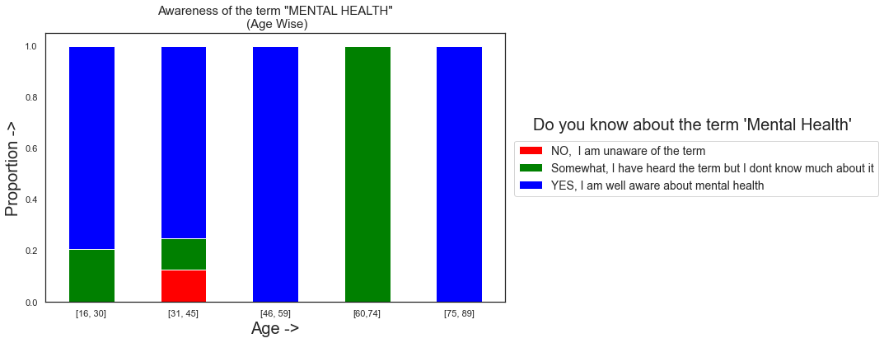

Age-wise Awareness of the respondents of the term MENTAL HEALTH

**Analysis:**

From the above STACKED BAR DIAGRAM we can clearly observe that most of the repondents are either well aware of the term “MENTAL HEALTH” or they somewhat know about the term “MENTAL HEALTH”.

Taking in regards some bias we can also conclude that the age groups (16-28),(40-52) and (76-89) are mostly aware of the term mental health.

However, in the age group (29-40) there is a round about 15% respondents who are totally unaware of the term “MENTAL HEALTH” and in the age group (65-76) no respondents completely know about the term “MENTAL HEALTH”

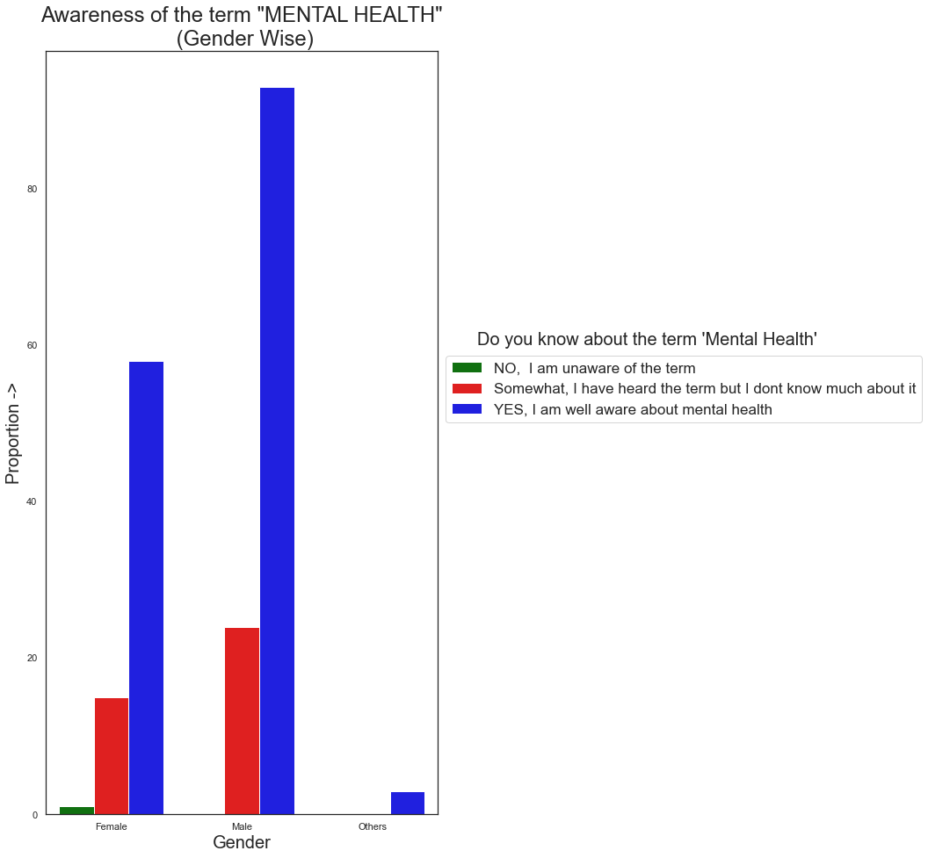

Gender-wise Awareness of the respondents of the term MENTAL HEALTH

**Analysis:**

From the above MULTIPLE BAR DIAGRAM we can clearly observe that most of the repondents are either well aware of the term “MENTAL HEALTH” or they somewhat know about the term “MENTAL HEALTH”.

Taking in regards some bias we can also conclude that the Males and the “Others” Gender are more aware of the term mental health than females.

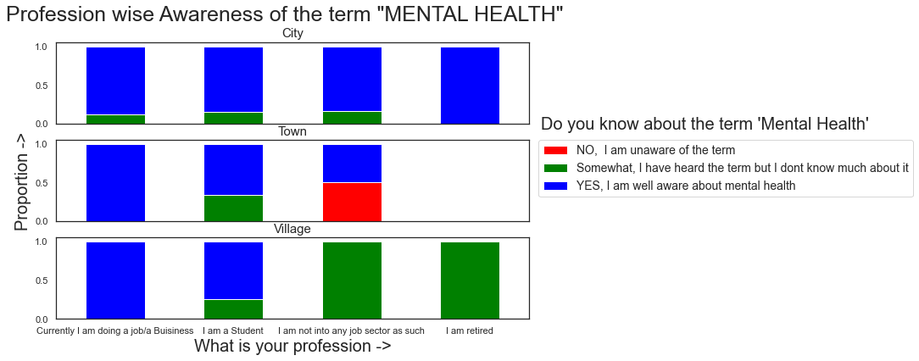

Profession-wise Awareness of the respondents of the term MENTAL HEALTH

(in accordance to the place of residence)

**Analysis:**

From the above STACKED BAR DIAGRAM we can clearly observe that most of the repondents are either well aware of the term “MENTAL HEALTH” or they somewhat know about the term “MENTAL HEALTH”.

Taking in regards some bias we can also conclude that the people who are in some kind of job sectors or business sectors are way more aware about the term “MENTAL HEALTH” than the rest irrespective of the place of residence and no respondents who are not in any job sectors are fully aware of the term.

Also we can clearly observe that respondents residing in cities are more aware about the term “MENTAL HEALTH” than those residing in town or villages.

However, we can also see that round about 50% of the respondents who are not in any job sectors as such and are residing in towns are completely unaware of the term.

1. **EDA of the respondents attending courses or training programs involving Mental Health Awareness**

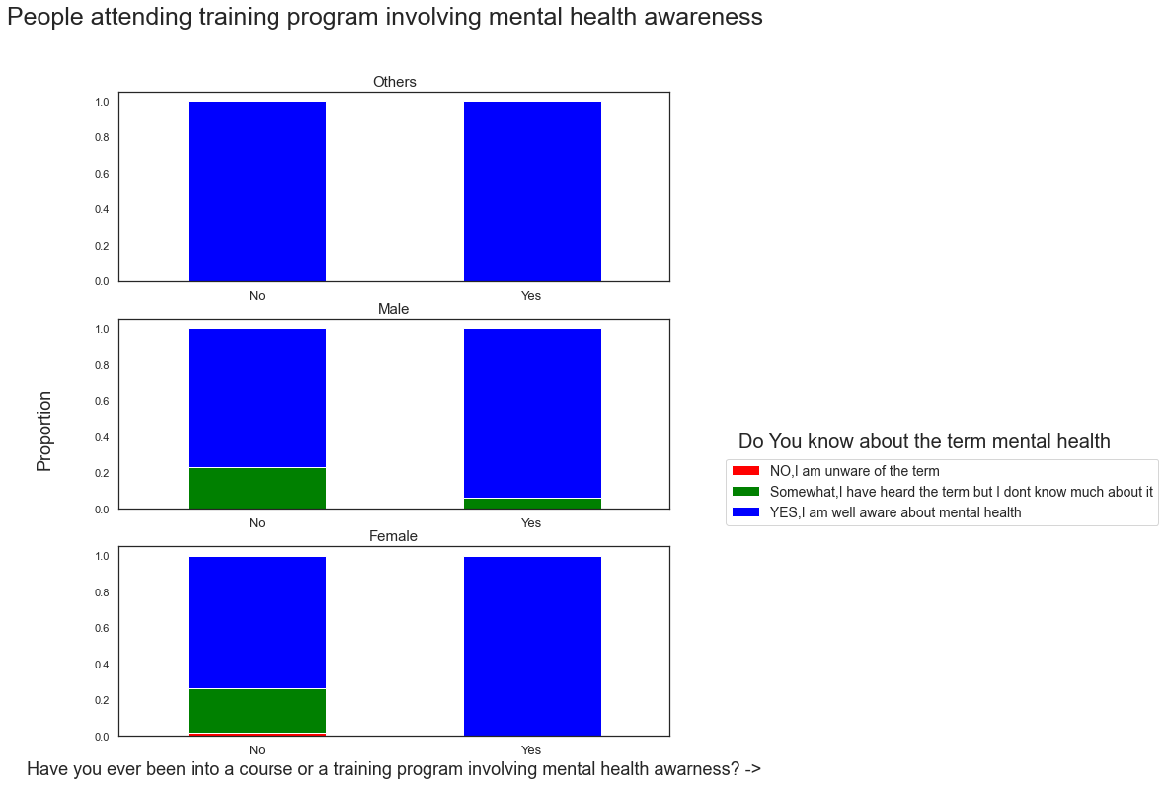 Analysis of the respondents attending courses or training programs involving Mental Health Awareness

(According to their knowledge of the term Mental Health and Gender)

**Analysis:**

From the above SCATTER PLOT DIAGRAM we can clearly observe that not much of the respondents have attended the courses or training programs involving Mental Health AwarenessTaking in regards some bias we can also conclude that more males have attended than females or others.

However we can also conclude that a large proportion of males who are well aware of the term mental health have not attended any training program or course regarding mental health awareness and same conclusion can be drawn about the female respondents.

And for others there is a split in attending the training program or course.

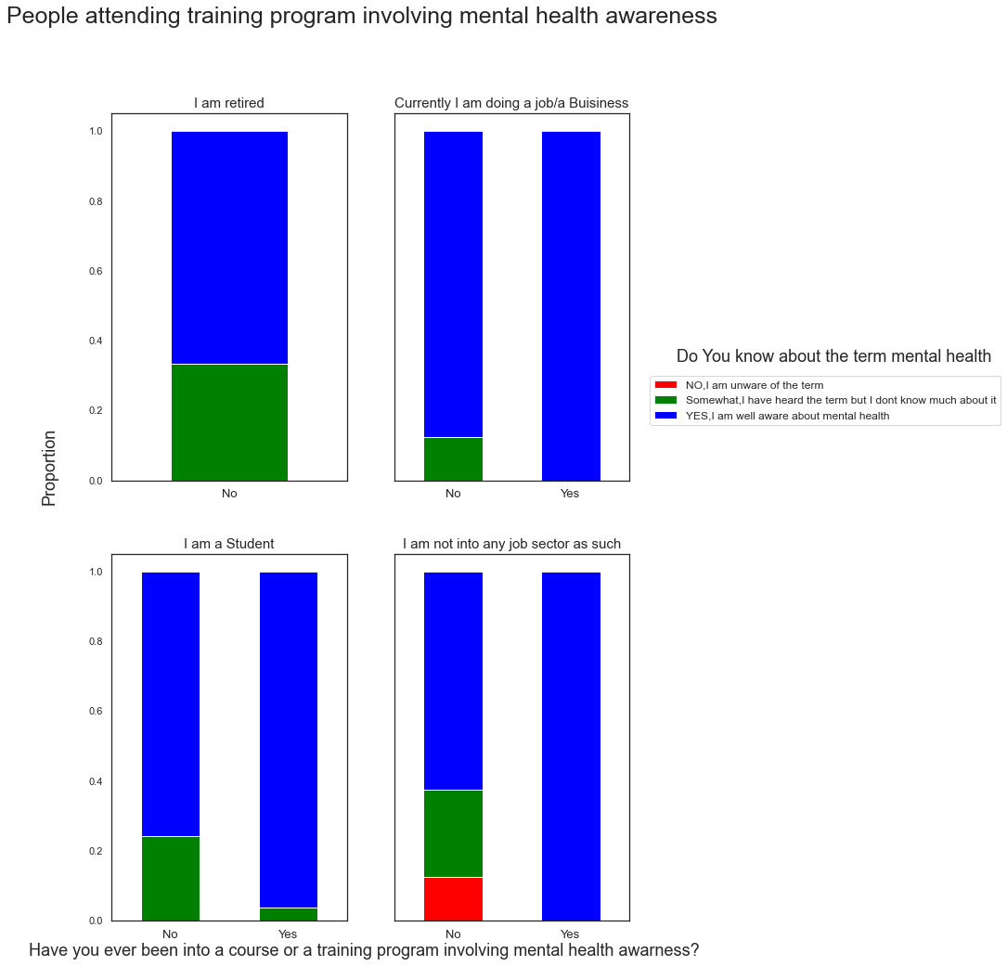

Analysis of the respondents attending courses or training programs involving Mental Health Awareness

(According to their knowledge of the term Mental Health and Profession)

**Analysis:**

From the above SCATTER PLOT DIAGRAM we can clearly observe that not much of the respondents have attended the courses or training programs involving Mental Health Awareness

Taking in regards some bias we can also conclude that mostly students and those who are in job sectors or business sectors have attended such training programs regarding mental health.

However we can also conclude that a large proportion of students who are well aware of the term mental health have not attended any training program or course regarding mental health awareness and same goes for those in job sectors.

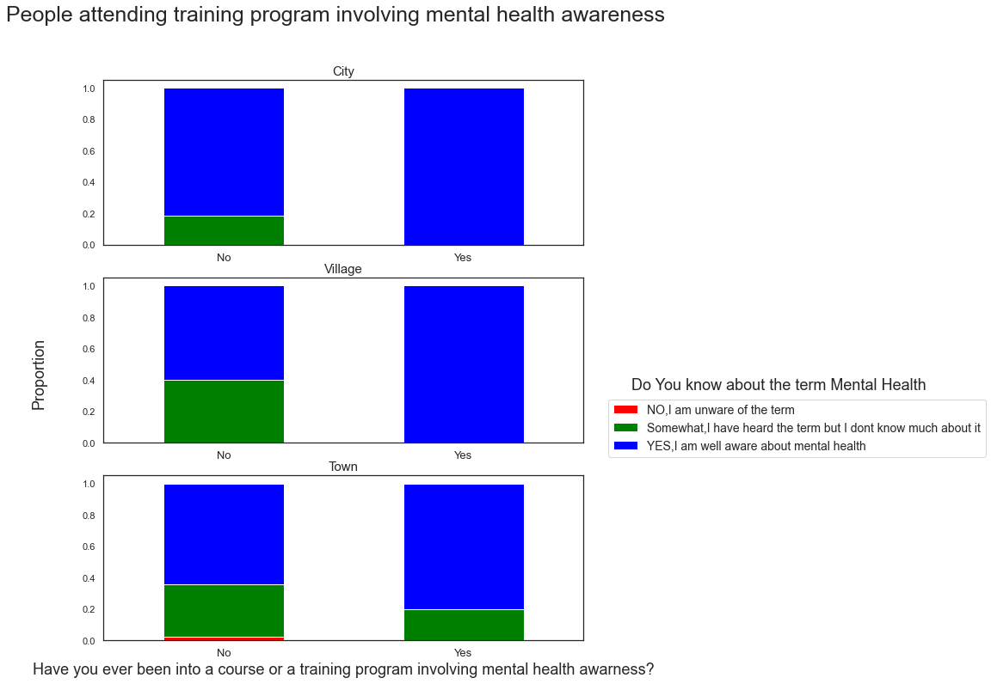 Analysis of the respondents attending courses or training programs involving Mental Health Awareness

(According to their knowledge of the term Mental Health and Place of Residence)

**Analysis:**

From the above SCATTER PLOT DIAGRAM we can clearly observe that not much of the respondents have attended the courses or training programs involving Mental Health Awareness

Taking in regards some bias we can also conclude that respondents residing in cities have attended more such training programs than those living in towns or villages.

However we can also conclude that a large proportion of respondents residing in cities who are well aware of the term mental health have not attended any training program or course regarding mental health awareness

And for respondents living in towns or villages very less have attended such programs or courses.

1. **EDA of the respondents recommending friends and relatives to any mental health professional based on their knowledge about the person experiencing any mental health issues**

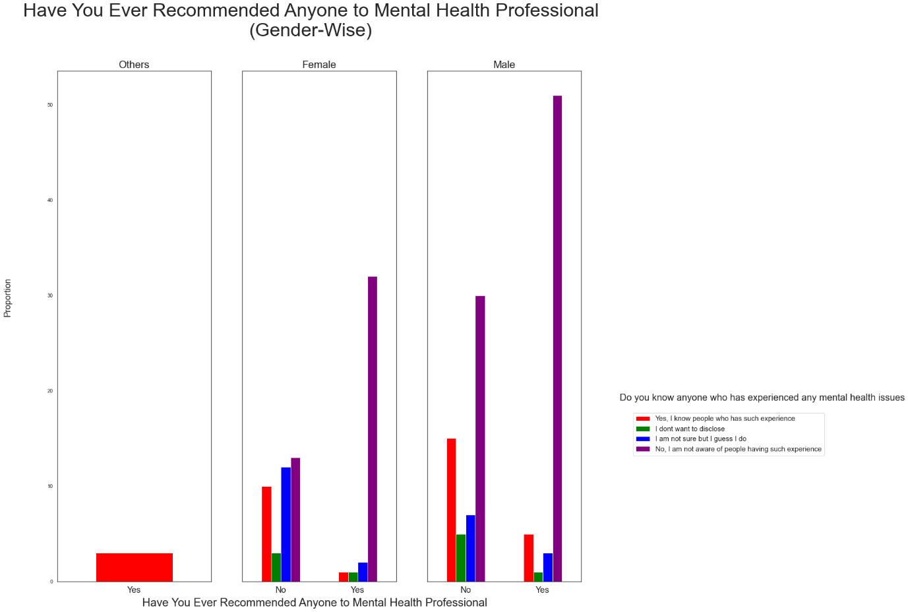Analysis of the respondents recommending friends and relatives to any mental health professional based on their knowledge about the person experiencing any mental health issues

(According to their Gender)

**Analysis:**

From the above MULTIP b LE BAR DIAGRAM we can clearly observe that a lot of respondents have known someone or the other who has gone through a mental health issue at a point and have even recommended them to a mental health professional.However there is a striking observation of respondents recommending friends or family members to a mental health professional without even getting sure about their mental health issues or even at times not at all being aware of the people having any mental health issues.Taking in regards some bias we can also conclude that there is a high frequency of “males” who have recommended friends and family members to the health professionals.However, there is a high frequency of males who have not recommended anyone to any mental health professionals even knowing that the person has experienced a mental health issue.And for “others” we see that respondents have always recommended people experiencing mental health issues to professionals.Also for “females” there is a split in frequency in recommending and not recommending friends and family members to the health professionals and there is also a lot of females who have not recommended anyone to any mental health professionals even knowing that the person has experienced a mental health issue.

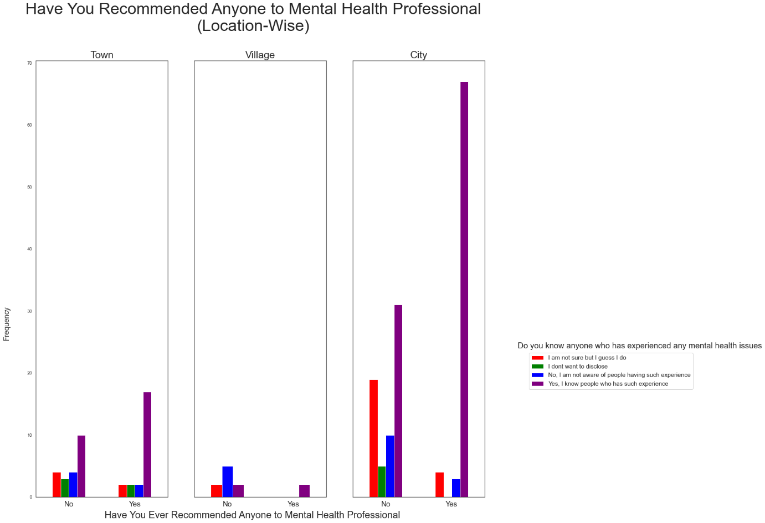 Analysis of the respondents recommending friends and relatives to any mental health professional based on their knowledge about the person experiencing any mental health issues

(According to their Place of Residence)

**Analysis:**

From the above MULTIPLE BAR DIAGRAM we can clearly observe that a lot of respondents have known someone or the other who has gone through a mental health issue at a point and have even recommended them to a mental health professional.

Taking in regards some bias we can also conclude that there is a high frequency of respondents from city who have recommended friends and family members to the health professionals which is more than those residing in towns or villages.

However there is a striking observation of respondents from city of not recommending friends or family members to a mental health professionals even knowing that the person has experienced a mental health issue.

Also in both cities and towns there is a striking observation of respondents recommending friends or family members to a mental health professional without even getting sure about their mental health issues or even at times not at all being aware of the people having any mental health issues.

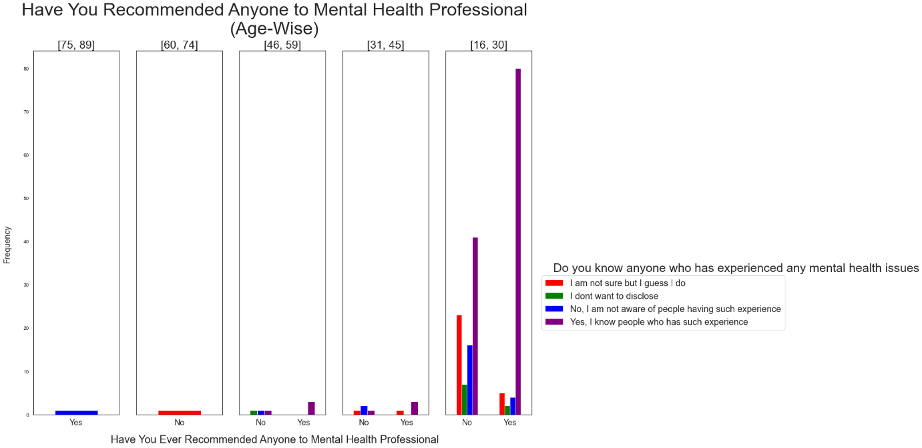 Analysis of the respondents recommending friends and relatives to any mental health professional based on their knowledge about the person experiencing any mental health issues

(According to their Age Groups)

**Analysis:**

From the above MULTIPLE BAR DIAGRAM we can clearly observe that a lot of respondents have known someone or the other who has gone through a mental health issue at a point and have even recommended them to a mental health professional.

Taking in regards some bias we can also conclude that there is a high frequency of respondents in the age group (16-28) who have recommended friends and family members to the health professionals.

However there is a striking observation that a lot of respondents in the age group (16-28) has recommended friends or family members to a mental health professional without even getting sure about their mental health issues or even at times not at all being aware of the people having any mental health issues.

In the other age groups there is a split in frequency in recommending and not recommending friends and family members to the health professionals

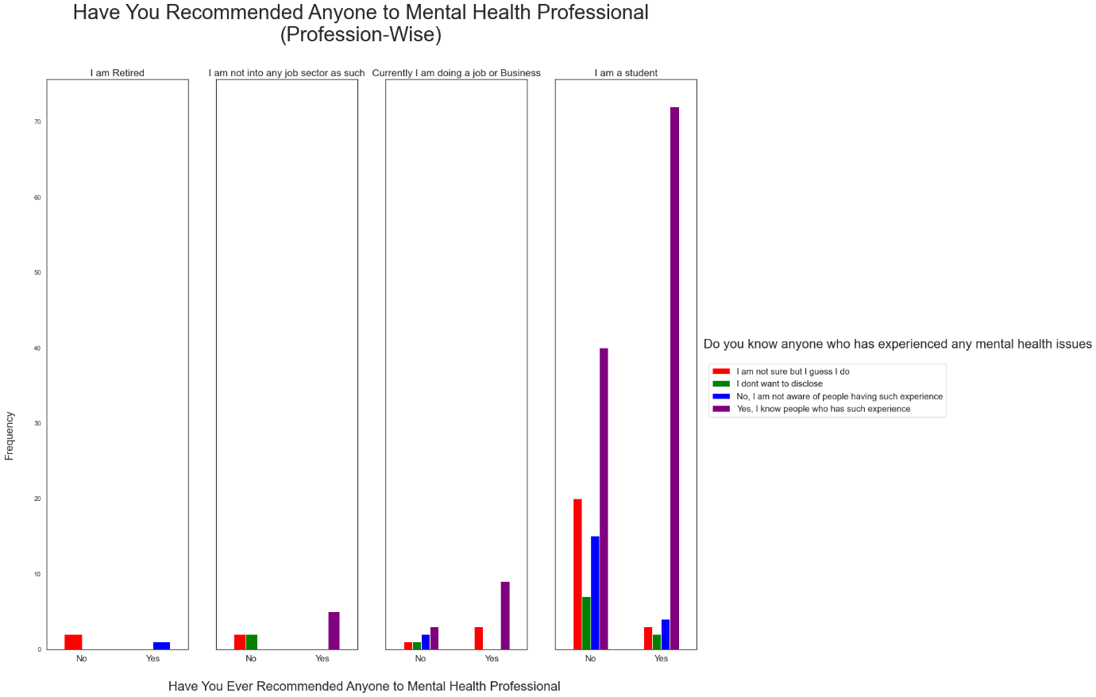 Analysis of the respondents recommending friends and relatives to any mental health professional based on their knowledge about the person experiencing any mental health issues

(According to their Profession)

**Analysis:**

From the above MULTIPLE BAR DIAGRAM we can clearly observe that a lot of respondents have known someone or the other who has gone through a mental health issue at a point and have even recommended them to a mental health professional..

Taking in regards some bias we can also conclude that there is a high frequency of respondents who are students have recommended friends and family members to the health professionals

However, there is also a high frequency of students who have not recommended anyone to any mental health professionals even knowing that the person has experienced a mental health issue.

And for other respondents who are in job sectors or business there are very few who have also have recommended friends and family members to the health professionals even without knowing if they really have any mental health issues

On the other hand there are some respondents in both job sectors as well as those who are not into any jobs have not recommended friends or family members to a mental health professionals even knowing that the person has experienced a mental health issue.

1. **EDA of the respondents feeling comfortable about sharing physical and mental health conditions with friends and family**

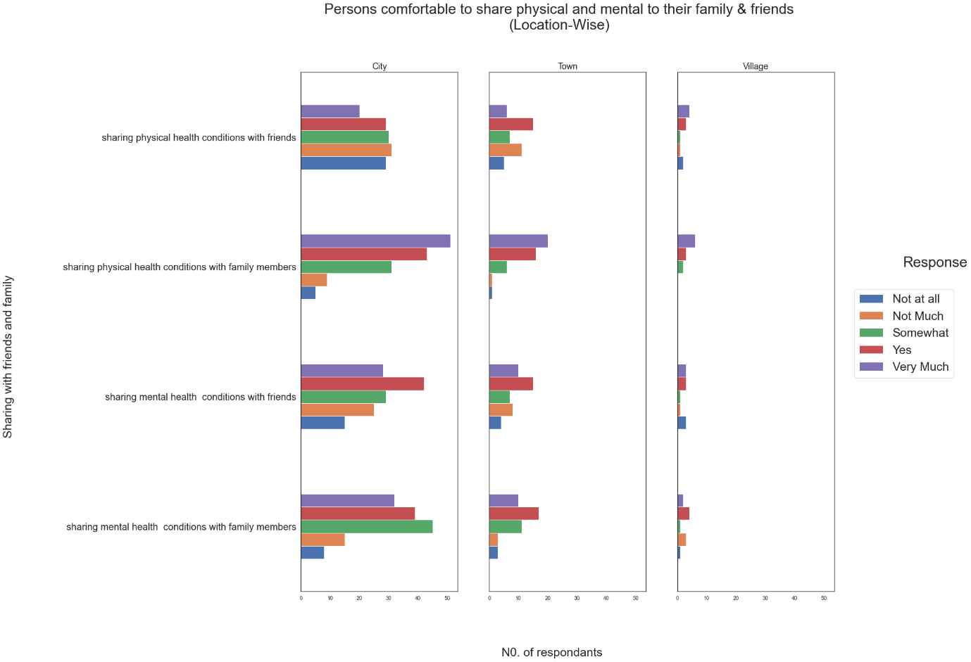Analysis of the respondents feeling comfortable about sharing physical and mental health conditions with friends and family

(According to their place of residence)

**Analysis:**

From the above MULTIPLE HORIZONTAL BAR DIAGRAM we can clearly observe that in cities respondents are way more comfortable in sharing physical health with family members than mental health.

Also in cities the respondents are more comfortable in sharing mental health condition with friends than with family members however they are not that comfortable in sharing physical health conditions with friends.

In towns also we observe the same trend of respondents being way more comfortable in sharing physical health with family members than mental health.

However here the respondents have somewhat the same opinion about sharing mental health conditions with friends and family members which is they are comfortable at an extent but not fully.

In village areas we see the respondents are comfortable in sharing physical health and mental health conditions with both friends and family members.

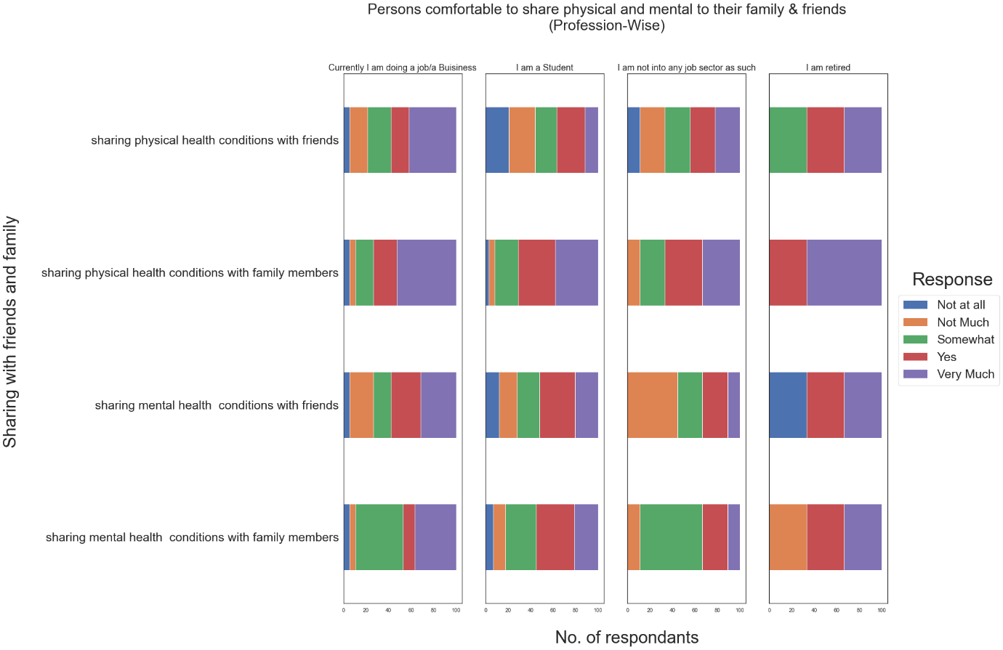 Analysis of the respondents feeling comfortable about sharing physical and mental health conditions with friends and family

(According to their Profession)

**Analysis:**

From the above MULTIPLE HORIZONTAL BAR DIAGRAM we can clearly observe that students are way more comfortable in sharing physical health conditions with family members than with their friends

Also among students we can observe that they are more comfortable in sharing mental health condition with friends than with family members

For respondents in job sectors they are more comfortable in sharing both physical and mental health with family members. However there are some respondents who are comfortable in sharing their both mental and physical health conditions with friends.

For those who are retired and not in any job sectors as such the respondents are way more comfortable in sharing physical health conditions than mental health condition to both friends and family members.

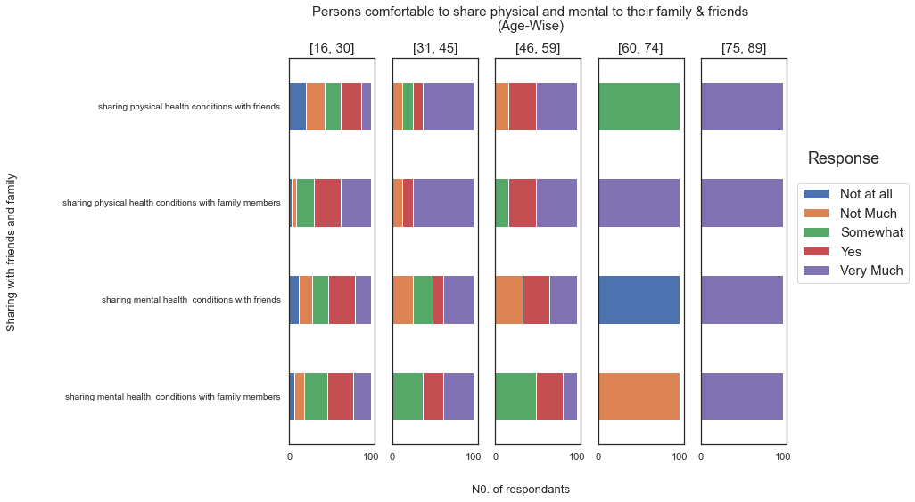 Analysis of the respondents feeling comfortable about sharing physical and mental health conditions with friends and family

(According to the Age Groups)

**Analysis:**

From the above STACKED HORIZONTAL BAR DIAGRAM we can clearly observe that in the age group (16-28) the percentage of respondents comfortable in sharing physical health conditions with their family members is way more than that of sharing physical health conditions with their friends signifying their comfortability with family members for sharing physical health conditions.

For sharing mental health conditions the respondents in the age group (16-28) is a bit more comfortable with friends than with family members.

In the age groups (29-40) and (41-52) the respondents are more comfortable in sharing both physical and mental health conditions with family members than with their friends which is evident from the percentage of responses.

However taking in regards the bias we can also conclude that the respondents in the age group (65-76) the respondents are more comfortable in sharing mental and physical health condition with the family members.

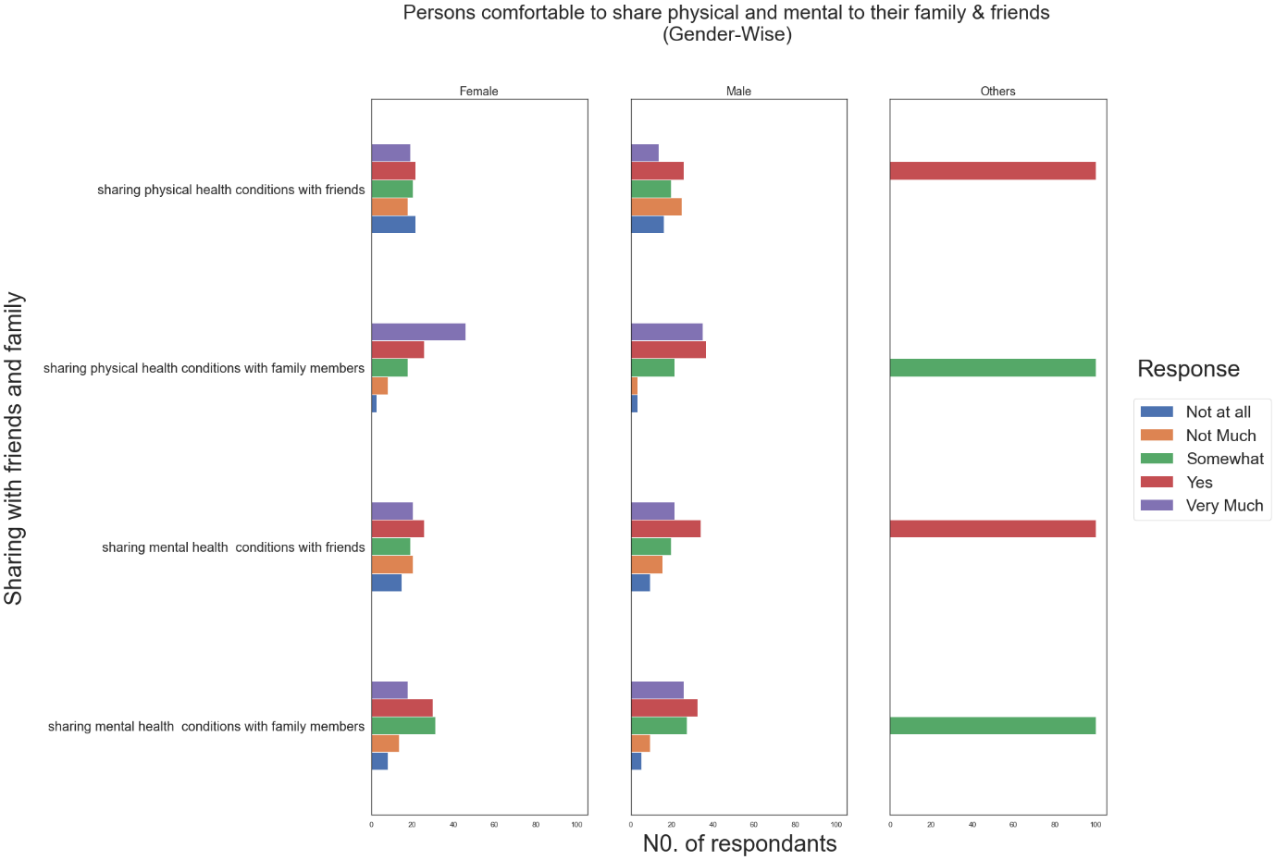 Analysis of the respondents feeling comfortable about sharing physical and mental health conditions with friends and family

(According to their Gender)

**Analysis:**

From the above MULTIPLE HORIZONTAL BAR DIAGRAM we can clearly observe that respondents who are males are way more comfortable in sharing both physical and mental health conditions with family members than with their friends.

As we can also see there is high frequency among male respondents who are not at all comfortable with sharing mental health conditions with their family members.Consequently the male respondents are way more comfortable in sharing mental heath conditions with their friends than with their family members.Among respondents who are females there is a high frequency of respondents who are very much comfortable in sharing physical health conditions to their family members.

However for mental health conditions the female respondents are somewhat comfortable in sharing with both friends and family members.

For Others the respondents are also more comfortable in sharing physical health conditions to their family members and for mental health conditions there is a split in frequency.

1. **EDA of the respondents’ ratings to different platforms for their roles in the spread of mental health awareness in our society**

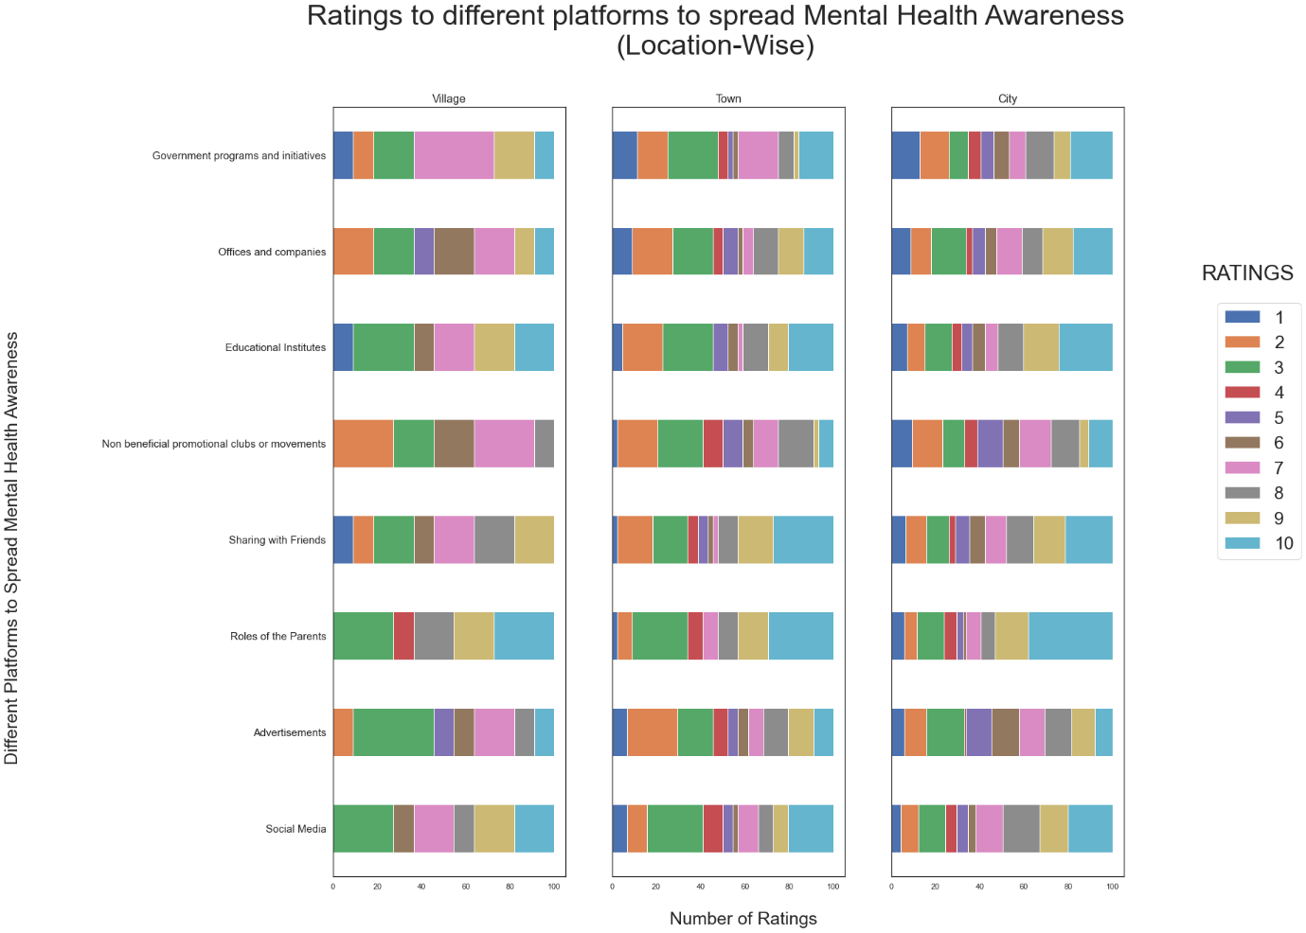

Analysis of the respondents’ ratings to different platforms for their roles in the spread of mental health awareness in our society

(According to their Place of Residence)

**Analysis:**

Taking into consideration some bias we can observe from the above MULTIPLE HORIZONTAL BAR DIAGRAM that in cities maximum number of respondents rate “The role of the parents” as the most useful platform followed by “Educational Institutes”, “Sharing with Friends”, “Social Media” , “Government Programs and Initiatives”, “Offices and Companies” , “Non Beneficial Clubs or Movements” , “Advertisements” in the order. We can also observe that a high frequency respondents in the cities have also poorly rated “Government Programs and Initiatives” along with “Offices and Companies” and “Non Beneficial Clubs or Movements”.In towns we observe round about the same trend of rating with a change of “Sharing with Friends” getting more better ratings than “Educational Institutes” .However the frequency for poor ratings is higher in case of “Offices and Companies”, “Educational Institutes”, “Advertisements” for respondents residing in towns. And the same trend continues for respondents residing in villages as well..

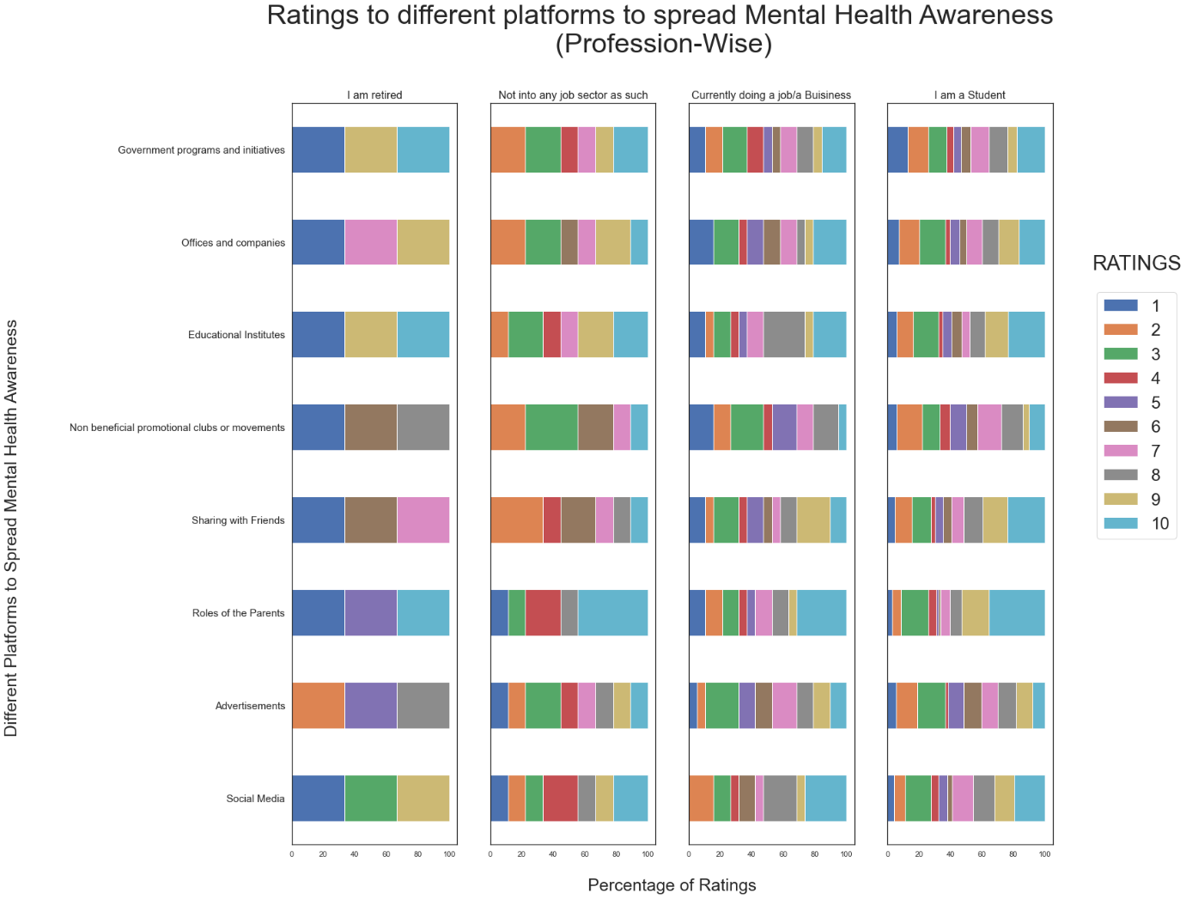 Analysis of the respondents’ ratings to different platforms for their roles in the spread of mental health awareness in our society

(According to their Profession)

**Analysis:**

Taking into consideration some bias we can observe from the above MULTIPLE HORIZONTAL BAR DIAGRAM that maximum number of respondents who are students rate “The role of the parents” as the most useful platform followed by “Educational Institutes”, “Sharing with Friends”, “Social Media” , “Government Programs and Initiatives”, “Offices and Companies” , “Non Beneficial Clubs or Movements” , “Advertisements” in the order.

We can also observe that a high frequency respondents who are students have poorly rated “Government Programs and Initiatives”

And the trend remains same for respondents who are in job sectors and not in job sectors and those who are retired.

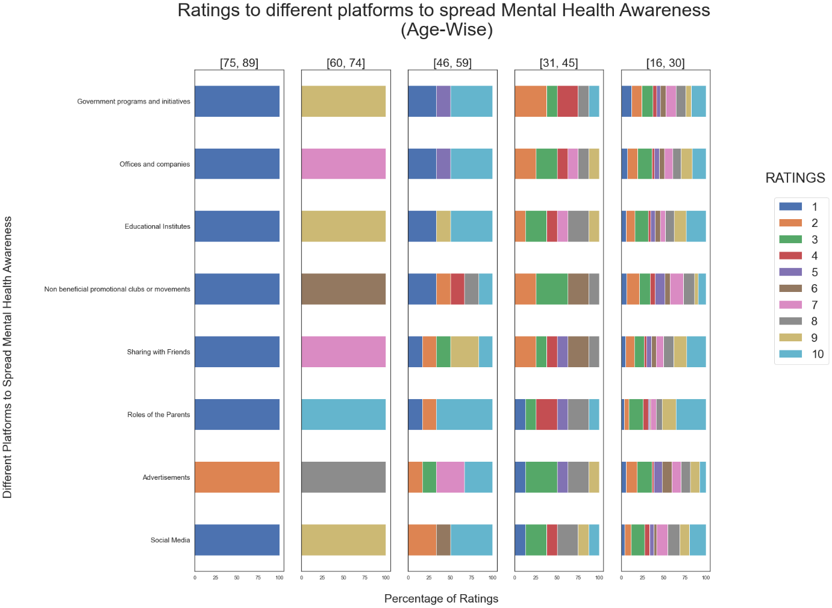 Analysis of the respondents’ ratings to different platforms for their roles in the spread of mental health awareness in our society

(According to their Age Groups)

**Analysis:**

Taking into consideration some bias we can observe from the above STACKED HORIZONTAL BAR DIAGRAM that maximum percentage of respondents who are in the age group (16-28) rate “The role of the parents” as the most useful platform followed by “Educational Institutes”, “Sharing with Friends”, “Social Media” , “Government Programs and Initiatives”, “Offices and Companies” , “Non Beneficial Clubs or Movements” , “Advertisements” in the order.We can also observe that a high percentage of respondents who are in the age group (16-28)have poorly rated “Government Programs and Initiatives”

For the age groups (29-40) and (41-52) the respondents have rated round about the same with “The role of the parents” being the best rated followed by “Social Media”, “Educational Institutes”, “Sharing with Friends”, , “Government Programs and Initiatives”, “Offices and Companies” , “Non Beneficial Clubs or Movements” , “Advertisements” in the order.

In the age group (29-40) the respondents have also poorly rated “Government Programs and Initiatives” and “Advertisements” however in the age group (41-52) the poorly rated platforms are “Government Programs and Initiatives”, “Offices and Companies” and “Non Beneficial Clubs or Movements”.For the age group (65-76) the highest rated platform is “The role of the parents” and the lowest rated platform is “Non Beneficial Clubs or Movements”.

For the age group (77-89) respondents rate only “Advertisements”

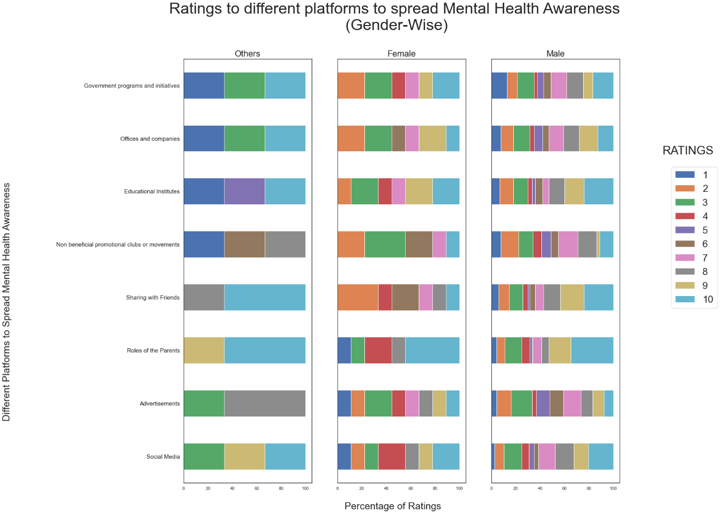 Analysis of the respondents’ ratings to different platforms for their roles in the spread of mental health awareness in our society

(According to their Gender)

**Analysis:**

Taking into consideration some bias we can observe from the above MULTIPLE HORIZONTAL BAR DIAGRAM that maximum number of respondents who are males rate “The role of the parents” as the most useful platform followed by “Educational Institutes”, “Sharing with Friends”, “Social Media” , “Government Programs and Initiatives”, “Offices and Companies” , “Non Beneficial Clubs or Movements” , “Advertisements” in the order.

We can also observe that a major number of respondents who are males have poorly rated “Government Programs and Initiatives”

The same trend is almost followed for the respondents who are females

However the female respondents have poorly rated mostly “Advertisements” and “Government Programs and Initiatives”.

For others the major number of respondents have rated “The role of the parents” and “Sharing with Friends” the best options to share such awareness.

1. **EDA of the respondents’ views on effect of COVID-19 on mental stress**

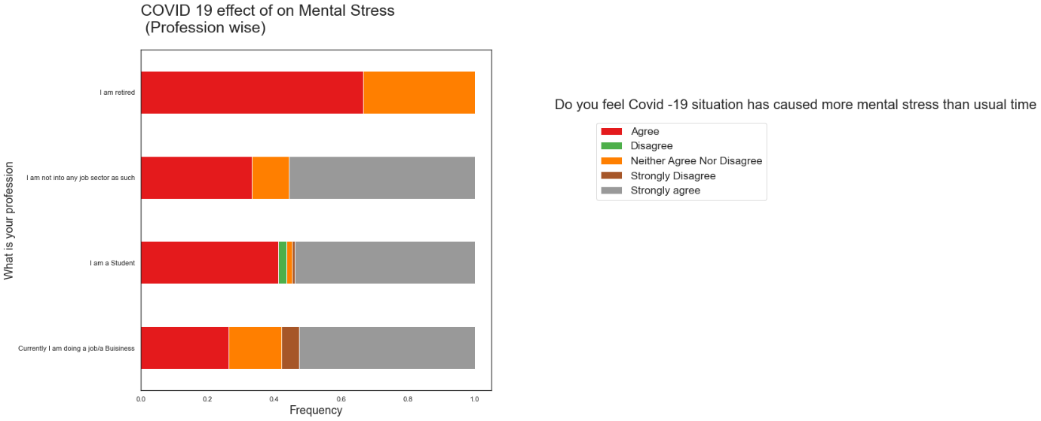 Analysis of the respondents’ views on effect of COVID-19 on mental stress

(According to their Profession)

**Analysis:**

Taking into consideration some bias we can observe from the above STACKED HORIZONTAL BAR DIAGRAM that a major percentage of respondents who are currently doing a job or a Business agree that COVID-19 has effected more on mental stress than usual times with a good percentage of them strongly agreeing to the notion

However small percentage of the group of respondents have strongly disagreed.

For students the percentage Agreeing and Strongly Agreeing also accounts to the majority of the respondents in the group with a small percentage Disagreeing and Strongly Disagreeing to the notion.

For respondents in not any job sectors as such almost 75% of the respondents have Agreed and Strongly Agreed to the notion that Covid-19 has surely caused more mental stress than usual times with the rest having no conclusive decision as such.

For the respondents who have retired every one has agreed to the notion.

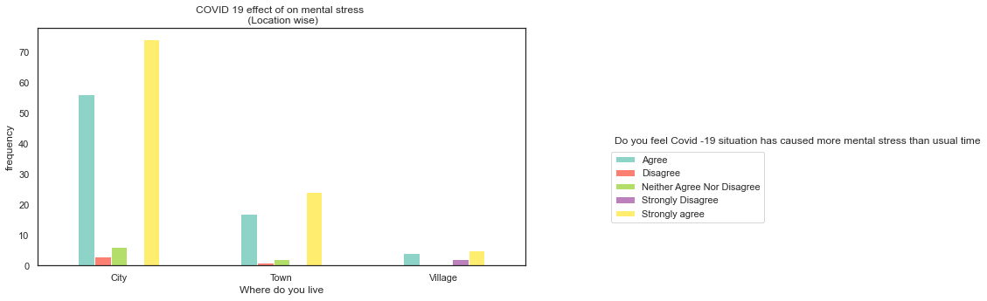

Analysis of the respondents’ views on effect of COVID-19 on mental stress

(According to their Place of Residence)

**Analysis:**

Taking into consideration some bias we can observe from the above MULTIPLE BAR DIAGRAM that a large number of respondents from the city Agrees and Strongly Agrees that COVID-19 has effected more on mental stress than usual times

Even in towns we see the same trend with the majority of the respondents agreeing to the notion along with a good number of respondents strongly agreeing.

For respondents in villages too the majority agrees that covid-19 has caused more mental stress than usual time. However small percentage also strongly disagrees.

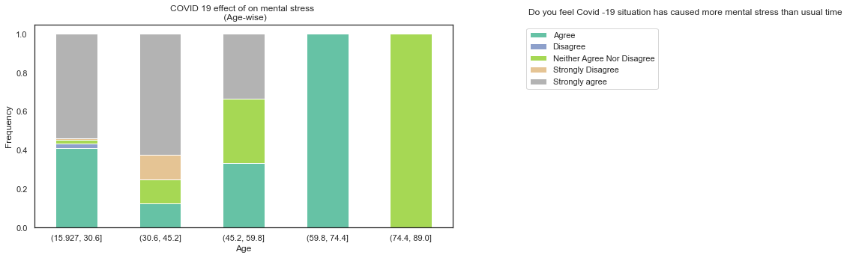 Analysis of the respondents’ views on effect of COVID-19 on mental stress

(According to the Age Groups)

**Analysis:**

Taking into consideration some bias we can observe from the above STACKED BAR DIAGRAM that a large number of respondents in the age group (16-28) Agrees and Strongly Agrees that COVID-19 has effected more on mental stress than usual times with a small percentage disagreeing to the above notion.

For the age group (29-41) the same agreement over the notion can be observed , however there is a small percentage who strongly disagrees.

For the other three age groups almost everyone agrees to the notion , however the respondents in the age group (77-89) do not have any conclusive decision about the notion.

1. **EDA of the respondents’ views on enough importance given to mental health issues by the people around them**

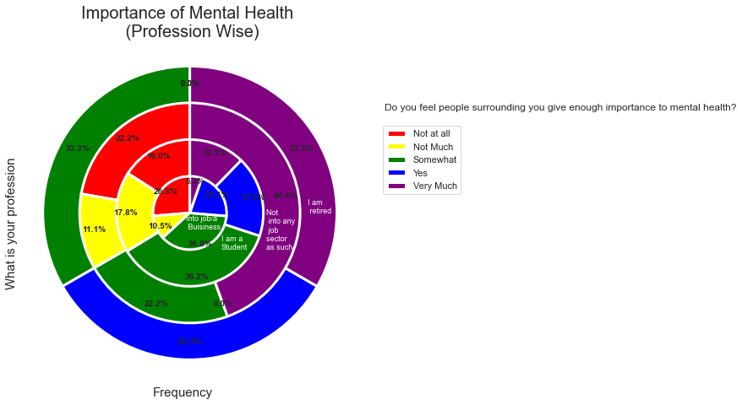

Analysis of the respondents’ views on enough importance given to mental health issues by the people around them

(According to their Profession)

**Analysis:**

Taking into consideration some bias we can observe from the above Pie chart that a large proportion of respondents who are doing jobs or business feel that people around them give somewhat importance to mental health however the second largest proportion of respondents of the group feels that people around them give no importance at all with the fourth highest proportion also disagreeing to the fact that people give enough importance to mental health. The rest however agrees that people around give enough importance to mental health

For students the trend remains round about the same as in for those in business or job sectors.

For the people not into any job sectors as such the majority proportion very much feels that people surrounding them give enough importance to mental health. However the second major proportion feels just the opposite as in people around don’t give not much importance to mental health.

For those who are retired everyone feels people give either very much importance or somewhat importance to mental health.

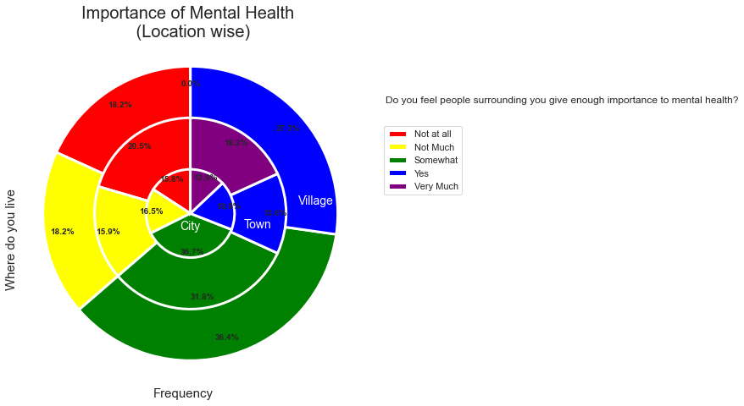 Analysis of the respondents’ views on enough importance given to mental health issues by the people around them

(According to their Place of Residence)

**Analysis:**

Taking into consideration some bias we can observe from the above Pie chart that a large proportion of respondents who are living in the cities feel that people around them give somewhat importance to mental health however; although half of the rest supports the notion the other half completely disagrees that people give enough importance to mental health

For those living in towns the majority feels people around them give somewhat importance to mental health and half of the rest feels people around them give importance to mental health while the other half completely disagrees

For those who reside in villages no respondents feel people around give very much importance to mental health. However , the majority feels people give somewhat importance to mental health.

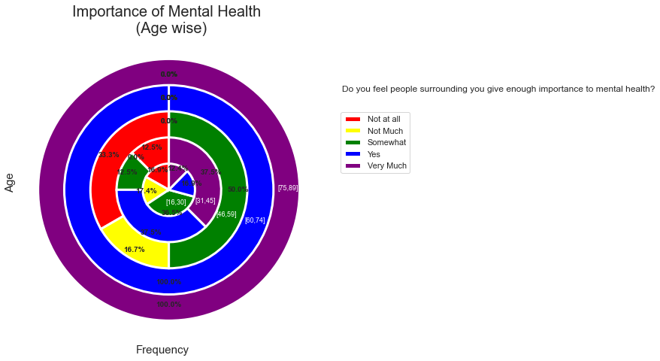 Analysis of the respondents’ views on enough importance given to mental health issues by the people around them

(According to their Age Groups)

**Analysis:**

Taking into consideration some bias we can observe from the above Pie chart that a large proportion of respondents who are in the age groups (16-28),(29-40) and (41-52) feel that people around them give somewhat importance to mental health.

In the age group (16-28) though half of the rest supports the notion the other half completely disagrees that people give enough importance to mental health

In the age group (29-40) the majority of the rest feels people around do give importance to mental health with a small proportion completely disagreeing this.

In the age group (41-52) the majority of the rest feels that people around does not give much importance to mental health with a small proportion feeling that people around give very much importance to mental health.

For the age group (65-76) respondents feel people around give importance to mental health.

And lastly for the age group (77-89) respondents feel give very much importance to mental health.